

**Physical Education Studies**

**Units 1 & 2**

**2019**

# Marking Key

**Section One – Multiple Choice**

|  |  |
| --- | --- |
| **Question** | **Answer** |
| 1 | B |
| 2 | D |
| 3 | B |
| 4 | A |
| 5 | C |
| 6 | A |
| 7 | C |
| 8 | C |
| 9 | D |
| 10 | D |
| 11 | C |
| 12 | B |
| 13 | C |
| 14 | A |
| 15 | B |
| 16 | C |
| 17 | C |
| 18 | A |
| 19 | A |
| 20 | D |

**Section Two: Short answer 50% (50 marks)**

This section has **ten (10)** questions. Answer **all** questions. Write your answers in the spaces provided. Use a blue or black pen (**not** pencil) for this section.

Supplementary pages for the use of planning/continuing your answer to a question have been provided at the end of this Question/Answer booklet. If you use these pages to continue an answer, indicate at the original answer where the answer is continued, i.e. give the page number.

Suggested working time: 70 minutes.

**Question 21 (7 marks)**

The following questions relate to Helen who is a 45 year old healthcare worker. She has recently started a new gym program as she is wanting to improve her muscular strength and bone density.

The image shows Helen completing a squat as part of her new gym program.



(a) When completing a squat, there are two obvious joint actions occurring in the legs. Identify the joint action occurring at Helen's knee and hip during the upwards phase of the squat.

(2 marks)

|  |  |
| --- | --- |
| Description | Marks |
| Knee - extension | 1 |
| Hip - extension | 1 |

(b) Identify the major muscle group allowing for the movement at the knee joint to occur.

(1 mark)

|  |  |
| --- | --- |
| Description | Marks |
| Quadriceps | 1 |

(c) Protection of vital organs is one function of the skeletal system. Identify 2 other functions of the skeletal system.

(2 marks)

|  |  |
| --- | --- |
| Description | Marks |
| Any 2 of the following   1. Provides framework for the body and gives it shape 2. Provides attachment points for muscles. 3. Stores essential minerals such as calcium and phosphorous which contribute to the health and maintenance of bone tissue. 4. Produces red blood cells (RBC’s) in the bone marrow | 2*1 |

(d) From a skeletal point of view, describe how the forearm and lower leg structures are similar.

(2 marks)

|  |  |
| --- | --- |
| Description | Marks |
| Any 2 of the following   * Both constructed of two bones (radius & ulna and Tibia & Fibula) * Both operate with a hinge joint * Both form a joint with a large, single more proximal bone (Humerus or Femur). | 2*1 |

**Question 22 (4 marks)**

The following question relates to the image below of a volleyball player performing a jump serve.

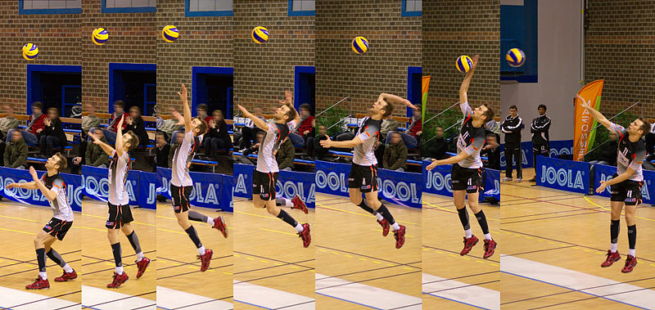

(a) Is this a gross or fine motor skill? Justify your response

(2 marks)

|  |  |
| --- | --- |
| Description | Marks |
| Gross | 1 |
| Involves movement of major muscle groups resulting in large body part movement | 1 |

(b) Is this a closed or open skill? Justify your response.

(2 marks)

|  |  |
| --- | --- |
| Description | Marks |
| Closed | 1 |
| * Take place in a stable, predictable environment where critical information does not change during the performance of the skill * Environment has little influence on performer * Or something similar | 1 |

**Question 23 (6 marks)**

The following graph displays data for two (2) athletes practicing their goal kicking in AFL.

(a) Using the data from the graph, identify which athlete was most likely to be in the

cognitive stage of learning. Justify your response

(3 marks)

|  |  |
| --- | --- |
| Description | Marks |
| Athlete B | 1 |
| Greater rate of improvement | 1 |
| Started at a lower level (i.e. lower success rate) | 1 |

(b) Using the data from the graph, identify which stage of learning the other athlete

was most likely to be in. Justify your response

(3 marks)

|  |  |
| --- | --- |
| Description | Marks |
| Athlete A – Associative stage | 1 |
| Reduced rate of improvement | 1 |
| Moderate level of performance | 1 |

**Question 24 (7 marks)**

The following image shows a gymnast performing a routine on a balance beam.

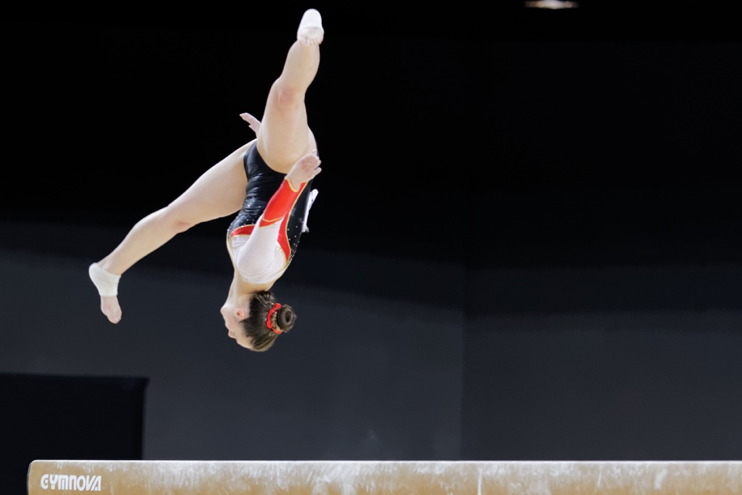

(a) Identify three strategies the gymnast could use to improve her stability when she

lands on the beam after performing the pictured movement.

(3 marks)

|  |  |
| --- | --- |
| Description | Marks |
| Any 3 of the following   * Lowering COG by flexing at the knees and hips * Increasing base of support by placing feet further apart on beam * Keeping Line of gravity inside base of support * Wrap feet/toes around beam to increase grip/support | 3*1 |

(b) To complete her routine, the gymnast is required to move up and down the beam

performing a series of movements to impress the judges. Discuss the difference

between the distance and displacement travelled by the gymnast throughout her

routine. Use examples to support your response.

(4 marks)

|  |  |
| --- | --- |
| Description | Marks |
| Distance – sum of all distances travelled by the gymnasts throughout her routine (or equivalent) | 1 |
| If the beam is 4m in length and she travels up and down it 7 times in her routine, then her distance travelled would be 28m (or similar example) | 1 |
| Displacement – difference between her starting position and her final position (or equivalent) | 1 |
| If the beam is 4m in length and she travels up and down it 7 times but finishes at the opposite end to which we started, her displacement would be 4m (or similar example) | 1 |

**Question 25 (5 marks)**

The following graph shows the varying contributions of fats and carbohydrates during submaximal exercise.

(a) At what point does the athlete make the switch to fats as the dominant fuel supply?

(1 mark)

|  |  |
| --- | --- |
| Description | Marks |
| Approx 2hr 45min (accept 2hr 30-2hr 50) | 1 |

(b) Explain the impact this is likely to have on their performance?

(2 marks)

|  |  |
| --- | --- |
| Description | Marks |
| Will cause a reduction in intensity | 1 |
| Due to fats being more difficult to break down/more complex reactions | 1 |

(c) Outline two nutritional strategies the athlete could use to delay the switching to fats

as the predominant fuel source.

(2 marks)

|  |  |
| --- | --- |
| Description | Marks |
| Any 2 of the following   * Carbohydrate load pre event to increase muscle glycogen stores * Consume Low GI pre event meal 1-4hrs before * Consume High GI foods during the event | 2*1 |

**Question 26 (10 marks)**

The following graph shows the relative contributions of the different energy systems during a four minute maximal intensity exercise bout.



(a) At what point does the anaerobic glycolysis system become the dominant energy

provider?

(1 mark)

|  |  |
| --- | --- |
| Description | Marks |
| Approx 10sec | 1 |

(b) Explain why there is a delay before the aerobic energy system becomes the

dominant provider. How does the body cater for this?

(3 marks)

|  |  |
| --- | --- |
| Description | Marks |
| At the commencement of exercise, the aerobic energy system is unable to supply ATP at the rate required by the body  or  at the start of exercise the body goes into oxygen deficit due to the discrepancy between the amount of oxygen required for exercise and the amount actually supplied. | 1 |
| This is due to the increased complexity of the reactions required to generate ATP | 1 |
| As a result the body uses the Anaerobic pathways to cover the shortfall in ATP during this time | 1 |

(c) At the 60sec mark, identify the fuel providing most energy for ATP production

(1 mark)

|  |  |
| --- | --- |
| Description | Marks |
| Glycogen | 1 |

(d) Discuss the concept of energy system interplay as it relates to the event in the graph

above.

(5 marks)

|  |  |
| --- | --- |
| Description | Marks |
| At the commencement of exercise, all 3 energy systems start contributing to the production of ATP at the same time | 1 |
| In the early stages of physical activity (0-5sec), the ATP-PC system makes the most significant contribution as it is able to produce ATP at the fastest rate, however runs out shortly after | 1 |
| When this system begins to deplete (at about the 5-6 sec mark) the Anaerobic Glycolysis system begins to take over as been the dominant provider of ATP and remains the dominant provider until about the 30sec mark. | 1 |
| From 30sec onwards the Aerobic system starts to produce ATP at a rate which meets the bodies demands for ATP and therefore becomes the dominant provider of ATP. | 1 |
| The Aerobic system remains the dominant provider for the remainder of the event unless exercise intensity increases, at which point the Anaerobic Glycolysis system increases in its contribution to the production of ATP. | 1 |

**Question 27 (4 marks)**

Davis Cup Tennis is a unique competition where players represent their country in a team event. Coaches and team mates sit on the sidelines and are permitted to provide feedback throughout the matches.

(a) Discuss the purpose of feedback in sport

(2 marks)

|  |  |
| --- | --- |
| Description | Marks |
| Any 2 of the following   * To motivate the performer * To change performance * To reinforce learning | 2*1 |

(b) Name and provide examples of two types of feedback that players would rely on in a

Davis Cup match to improve their performance

(2 marks)

|  |  |
| --- | --- |
| Description | Marks |
| Knowledge of results/external intrinsic Any relevant example relating to the outcome of the performance | 1 |
| Knowledge of performance/augmented Any relevant example relating to subjective feedback received about the performance | 1 |

**Question 28 (7 marks)**

Earlier this year, West Coast Eagles youngster Josh Rotham made his debut against Collingwood in front of over 61000 people at the MCG.

(a) Draw a graph to represent the inverted U hypothesis and identify where Josh is likely

to appear on the curve.

(3 marks)

|  |  |
| --- | --- |
| Description | Marks |
| Correctly labelled axis | 1 |
| Correct shape of curve | 1 |
| Correctly identify where Josh is likely to appear | 1 |

Expected that Josh is most likely going to be over aroused. Allow position to vary along the curve

Performance

Arousal

(b) Identify and describe two strategies Josh might have used on the day to help manage

his arousal levels

(4 marks)

|  |  |
| --- | --- |
| Description | Marks |
| Self-Talk: Talking or thinking to yourself | 1 mark definition (max 2)  1 mark application (max 2) |
| Any relevant example of application |
| Goal Setting: Is the process of deciding on something you want to achieve, planning the steps to follow that will help reach that goal, then working towards achieving that goal |
| Any relevant example of application |
| Relaxation: A series of activities undertaken to reduce tension and the effect of mental and physical stress. |
| Any relevant example of application |
| Performance Routine: The ritual an athlete undergoes before a given task. |
| Any relevant example of application |
| Imagery: The mental recreation, using as many senses as possible, of a successful past performance or skill. |
| Any relevant example of application |

**End of Section Two**

**Section Three: Extended answers 30% (30 marks)**

This section contains **four (4)** questions. You must answer **two (2)** questions. Write your answer in the spaces provided.

Supplementary pages for the use of planning/continuing your answer to a question have been provided at the end of this Question/Answer booklet. If you use these pages to continue an answer, indicate at the original answer where the answer is continued, i.e. give the page number.

Suggested working time: 50 minutes.

**Question 29 (15 marks)**

The following question relates to the images below.

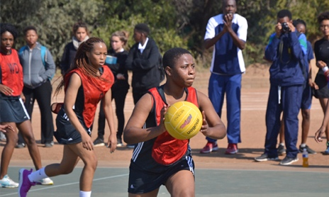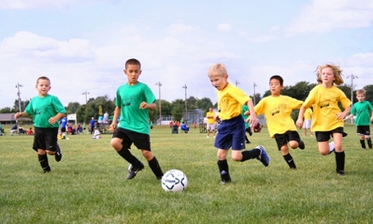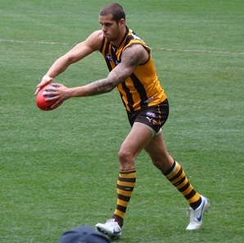

U/14’s youth netball

U/6 beginners’ soccer

Professional AFL player

(a) Identify and describe which stage of learning each of the pictured athletes above are

most likely in.

(9 marks)

|  |  |
| --- | --- |
| Description | Marks |
| Correctly identify stage of learning for each athlete (1 mark)  Provide 2 characteristics of each stage of learning (2@1 mark each) |  |
| Professional AFL player – Autonomous stage | 1 |
| Any 2 of the following   * Performers movements are fluent, well-coordinated and seemingly effortless * Increased speed and accuracy of response to a given situation * Attends to relative ques only - selective attention is high * Little variability in day to day performances * Ability to detect and self - correct errors * Skills are automated * Little attention to technique - focus more on application of tactics and strategies | 1-2 |
| U/6 beginners’ soccer – Cognitive stage | 1 |
| Any 2 of the following   * Performer learns nature and demands of the task/ * Performer is inconsistent (frequent errors) * More concerned with what to do rather than how to do it * Begins to develop the basic motor patterns * Movements are consciously controlled * Explanations / instructions and feedback must be kept simple. | 1-2 |
| U/14’s youth netball – Associative stage | 1 |
| Any 2 of the following   * Characterised by plenty of practice * Parts of the skill become automatically controlled * Consistency improves * Errors decrease * Internal feedback begins to be used * Selective attention improves. | 1-2 |

(b) The demands of a netball goal shot and AFL kick for distance vary greatly. Using the

biomechanical principles of segmental interaction and projectile motion, discuss the

differences between these two activities.

(6 marks)

|  |  |
| --- | --- |
| Description | Marks |
| Segmental interaction – refers to the way segments interact to produce a given force/meet the demands of the task  Netball goal shot – accuracy based and require body parts to move simultaneously  AFL kick for distance – body parts move sequentially to produce a maximal force | 1  1  1 |
| Projectile Motion - When angle, velocity and height of release combine to meet the demands of the task  Netball goal shot – height of release is less than landing height and therefore requires angle of release greater than 45 degrees  AFL kick for distance – height of release = landing height and therefore requires angle of release = 45 degrees | 1  1  1 |

**Question 30 (15 marks)**

In 2003 at the US Open semi-final, Justine Henin-Hardine completed what is widely recognised as the greatest comeback in female Tennis history. After being down 1 set to 0 and 5-3 in the 2nd set, Henin-Hardine managed to save two match points and send it to a 3rd and final set. Again, despite being down 5-2 in the 3rd set, she managed to somehow recover, winning 7-6 to clinch a spot in the Final.

(a) Discuss three (3) mental skill strategies Henin-Hardine could have used to maintain

her self-confidence throughout the match.

(9 marks)

|  |  |
| --- | --- |
| Description  1 mark for definition  1 mark for application  1 mark for example | Marks |
| **Goal Setting**  Definition - Goal setting is the process of deciding on something you want to achieve; planning the steps to follow that will help reach the goal, and then working towards achieving the goal.  Application - Can be used to assist with self-confidence through achieving short term goals  e.g. Henin-Hardine might focus on getting all her first serves in her next service game. | 1-3 |
| **Imagery**  Definition -the recreation of the performance, of a skill or group of skills, a previous positive experience or the picture of new events to prepare an individual mentally for performance.  Application - Imagery could be used to improve self-confidence by creating a mental picture of themselves performing aspects of their skills perfectly or hitting a winner  e.g. Henin-Hardine could create a mental picture of herself serving an ace or hitting a winner | 1-3 |
| **Performance Routines**  Definition -A performance routine is a ritual a performer follows in the preparation for or during the execution of a task or skill.  Application - Assist with improving self-confidence by allowing athlete to gather her thoughts and focus on demands of the situation, blocking out irrelevant cues etc  E.g. Henin-Hardine could use a routine such as prior to each serve, take 2 deep breaths, look at the point where she wants to serve, bounce the ball 3 times and execute. | 1-3 |
| **Self-Talk**  Definition - Involves talking to, or thinking to yourself, prior to or during performance.  Application - Positive self-talk can be used to improve self-confidence by reinforcing positive behaviours or previous successes  Henin-Hardine could say things like "I’ve beater her before, just get through this game” or “you’re playing well, you just need to make her hit one more shot” | 1-3 |
| **Relaxation**  Definition - An activity undertaken to reduce tension and the effects of physical and mental stress  Application – this could be used to increase self-confidence by helping the athlete relax and reduce muscle tension  e.g. Could use deep slow breathing to help relax and improve self confidence | 1-3 |

(b) Tennis tournaments such as the US Open require players to compete every second

day, potentially spending up to three hours on court each time they play. This places

huge stress on the body and requires elite physical preparation and optimal nutrition

practices if they want to be successful.

Outline a nutritional plan Justine could have used during and after each match to

help cope with the demands of the tournament.

(6 marks)

|  |  |
| --- | --- |
| Description  Any 6 of the following | Marks |
| During the match  Consume 150-200ml every 15 min to maintain hydration. Sports drinks can be used  Consume High GI CHO to maintain glycogen levels | 1  1 |
| Immediately after the match (0-30min)  Consume High GI CHO to commence restoration of muscle and liver glycogen  Commence fluid replacement. Sports drinks can be effective | 1  1 |
| After the match (1-24hrs)  Consume 1.5* fluid loss to return to normal hydration levels  Consume low GI CHO to restore muscle and liver glycogen levels  Consume protein to help with muscle repair | 1  1  1 |

**Question 31 (15 marks)**

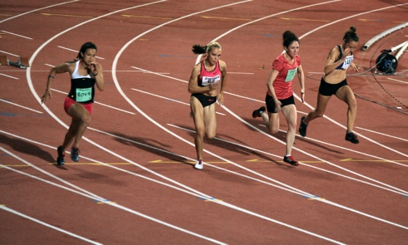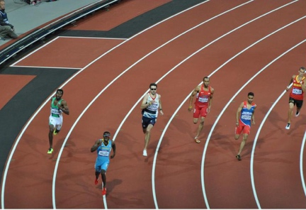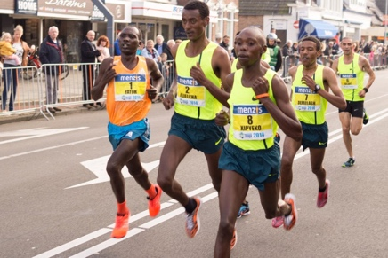

400m sprinter

Marathon runner

100m sprinter

(a) Using the three (3) athletes pictured above, discuss how the muscle fibre types would vary for each athlete. In your answer identify two (2) characteristics of each fibre type that would enable them to perform in their chosen event.

(9 marks)

|  |  |
| --- | --- |
| Description | Marks |
| 100m sprinter would have a very high percentage of Type IIB fibres | 1 |
| 400m sprinter would have a very high percentage of Type IIA fibres | 1 |
| Marathon runner would have a very high percentage of Type I fibres | 1 |
|  |  |
| Characteristics of each fibre type (max 2 per fibre type = 2 marks). The characteristic **must** relate to improving the athletes performance in the given event |  |
| Type II B fibres  Any 2 of the following   * Rapid contraction speed * Very High force production * Very large in diameter * Very large motor neuron * Very high glycolytic capacity | 2*1 |
| Ratios of fibres  80:20  60:40  20:80 | 2*1 |
| Type I fibres  Any 2 of the following   * High capillary density * High oxidative density * High mitochondrial density * Slow contraction speed * Low force production * Fatigue resistant | 2*1 |

(b) Discuss how each of Newton’s three (3) Laws relate to the 100m sprint.

(6 marks)

|  |  |
| --- | --- |
| Description  1 mark for definition  1 mark for application to running sprint | Marks |
| Newtons 1st law - A body continues in its state of rest or state of motion unless acted upon by a force  Application of Newtons 1st law – runner remains on starting block until force is created through contraction of muscles  Other relevant examples accepted | 1-2 |
| Newtons 2nd law - The acceleration of a body is proportional to the force applied to it, and inversely proportional to the mass of the object  Application of Newtons 2nd law – increase application of force in opposite direction results in greater acceleration  Other relevant examples accepted | 1-2 |
| Newtons 3rd law - For every action, there is an equal and opposite reaction  Application of Newtons 3rd law – pushing off the starting blocks, an equal and opposite force is applied sending the runner forward  or  runner applies a downwards and backwards force against the ground and the ground applies an equal and opposite force against the runner propelling them upwards and forwards  Other relevant examples accepted | 1-2 |

**Question 32 (15 marks)**

Two athletes set themselves the goal of competing in the London Marathon in 2020. Athlete A is considered a trained athlete, having competed in marathons previously and regularly trains. Athlete B is considered untrained, having never run a marathon before and currently lives a relatively sedentary lifestyle.

(a) Compare the maximal Cardiac Output, resting Heart rate and maximal Stroke

Volumes of Athlete A and B prior to starting their new training regimes. Furthermore

discuss two methods of training Athlete B could use to improve these dimensions.

(7 marks)

|  |  |
| --- | --- |
| Description | Marks |
| Athlete A will have a higher maximum cardiac output to that of Athlete B | 1 |
| Athlete A will have a higher maximum stroke volume to that of Athlete B | 1 |
| Athlete A will have a lower resting heart rate to that of Athlete B | 1 |
| Plus any 2 of the following |  |
| Continuous training | 1 |
| Form of training which involves non-stop exercise for a period of a minimum of 20min. | 1 |
| Fartlek Training | 1 |
| Modified version of continuous training involving continuous activity interrupted by random changes in pace | 1 |
| Long interval training | 1 |
| Series of repeated bouts of exercise interrupted by pre - determined rest periods or lighter exercise | 1 |

(b) Identify and outline four (4) long term respiratory adaptations Athlete B is likely to

receive as a result of a six (6) month aerobic training program.

(8 marks)

|  |  |
| --- | --- |
| Description | Marks |
| Any 4 of the following  1 mark identify  1 mark define/explain |  |
| **Increased ventilatory efficiency** | 1 |
| Ventilation has a lowered oxygen cost as more efficient gas exchange between alveoli and capillaries takes place. This allows more oxygen to be sent to working muscles | 1 |
| **Increased lung/vital capacity** | 1 |
| An increased lung capacity allows more oxygen to be inspired and then transported to the working muscles | 1 |
| **Decreased respiratory rate at rest, sub max exercise** | 1 |
| More efficient gas exchange results in reduced respiratory rate at rest and submaximal exercise | 1 |
| **Increased pulmonary diffusion capacity** | 1 |
| With training, an athlete uses more of the available alveoli resulting in an increased surface area available for gas exchange | 1 |
| **Increased tidal volume** | 1 |
| An increase in the volume of air inspired and expired with each breath. | 1 |

**End of Section Three**

**ACKNOWLEDGEMENTS**

Question 8 Image of golf driving range

<https://commons.wikimedia.org/wiki/File:Golf_Lounge_Hamburg5.jpg>

Question 12 Image of the heart

<https://commons.wikimedia.org/wiki/File:2008_Internal_Anatomy_of_the_HeartN.jpg>

Question 15 Image of 400m running race

<https://en.wikipedia.org/wiki/Shanti_Pereira>

Question 20 Image of penalty kick

<https://commons.wikimedia.org/wiki/File:Penalty_Ronaldinho_Montreal_Impact-AC_Milan.jpg>

Question 22 Image of squat

<https://pixabay.com/vectors/sport-sports-the-squat-squats-285773/>

Question 23 Image of volleyball serve

<https://commons.wikimedia.org/wiki/File:Serve_in_volleyball.jpg>

Question 25 Image of gymnast

<https://commons.wikimedia.org/wiki/File:Serve_in_volleyball.jpg>

Question 29 Image of Justine Buddy Franklin

<https://www.foxsports.com.au/afl/sydney-swans-injury-news-lance-franklin-dan-hannebery-to-miss-clash-with-north-melbourne/news-story/6b3a088154d8d7051d0809a5291127c5>

Question 29 Image of children’s soccer

<http://woodbridgectsoccer.org/>

Question 29 Image of youth netball

<https://www.begadistrictnews.com.au/story/2898959/bega-netball-try-day-attracts-new-youth-photos/>

Question 30 Image of Justine Henin-Hardine

<https://commons.wikimedia.org/wiki/File:Justine_henin_hardenne_medibank_international_2006_02.jpg>

Question 31 Image of 400m sprinter

<https://commons.wikimedia.org/wiki/File:Mens_400m_semi_final_3_-_2012_Summer_Olympics.jpg>

Question 31 Image of 100m sprinter

<https://commons.wikimedia.org/wiki/File:Athletics_Night_Competition_100m_women_sprint_29-07-2013.JPG>

Question 31 Image of marathon runner

<https://pixnio.com/sport/athletics/athlete-runner-competition-foot-race-race-marathon-sport-people>